Transactions & Funding Trends Analysis

Tools Used: Python, MySQL, Power BI
Dataset: Indian Startup Funding Dataset (Kaggle)

1. Project Overview
This project analyzes funding received by Indian startups between 2015–2019 to uncover insights about:
- Top industries receiving funding
- Leading startup locations
- Most active investors
- Preferred investment types
- Funding trends over the years
- Disclosed vs undisclosed deals
- Largest individual deals
The analysis helps investors, startup founders, and financial analysts understand how funding flows in the Indian startup ecosystem.
2. Problem Statement
Startups receive funding from various investors, industries grow differently, and cities attract different levels of investment. However:
- Funding data is scattered
- Trends are not easy to identify
- Many deals are undisclosed
- Investors follow different strategies
Goal:
To clean, analyze, and visualize Indian startup funding data and highlight key trends that help understand where money is flowing and why.

3. Business Objectives
- Identify top industries by number of deals & total funding
- Identify cities that dominate startup activity
- Find most active investors
- Analyze funding amounts by year
- Compare early-stage vs late-stage funding
- Identify startups receiving highest funding
- Measure undisclosed vs disclosed deals
- Calculate average deal size
- Discover funding patterns across investment types
4. Dataset Description
The dataset contains 3044 rows and 9 columns:
Column | Description
SrNo | Serial number
Date | Funding date (DD-MM-YYYY)
StartupName | Startup that received funding
IndustryVertical | Primary industry category
SubVertical | Sub-category
Location | City of the startup
InvestorsName | Investors involved in the deal
InvestmentType | Type of funding round
Amount | Funding amount (USD)
IsAmountDisclosed | 1 = disclosed, 0 = undisclosed

5. Data Cleaning (Python)
Data cleaning was performed using Pandas in Python.
Step 1: Remove unwanted characters
Removed special characters like \xa0 from text columns.
Step 2: Handle missing values
- Filled missing text fields with "Unknown"
- Kept missing numeric values as NaN
Step 3: Clean the Amount column
- Removed commas and currency symbols
- Converted to numeric using pd.to_numeric(..., errors="coerce")
Step 4: Convert date format
Converted date from
DD-MM-YYYY → datetime using:
pd.to_datetime(df['Date'], format="%d-%m-%Y", errors="coerce")
Step 5: Remove duplicates & clean whitespace
- Trimmed spaces
- Dropped duplicate rows
- Ensured consistent formatting

6. Data Analysis (MySQL Queries)
create table finance_data(
SrNo int,
Date date,
startupName varchar(170),
IndustryVertical varchar(170),
SubVertical varchar(170),
Location varchar(170),
InvestorsName varchar(270),
InvestmentType varchar(170),
Amount BIGint,
IsAmountDisclosed int
);

LOAD DATA INFILE 'E:/DA/projects/p1/FINANCE/Funding_data.csv'
INTO TABLE finance_data
FIELDS TERMINATED BY ','
OPTIONALLY ENCLOSED BY '"'
LINES TERMINATED BY '\n'
IGNORE 1 ROWS
(
@SrNo,
@Date,
@startupName,
@IndustryVertical,
@SubVertical,
@Location,
@InvestorsName,
@InvestmentType,
@Amount,
@IsAmountDisclosed
)
SET
SrNo = NULLIF(@SrNo, ''),
Date = STR_TO_DATE(NULLIF(@Date, ''), '%d-%m-%Y'),
startupName = NULLIF(@startupName, ''),
IndustryVertical = NULLIF(@IndustryVertical, ''),
SubVertical = NULLIF(@SubVertical, ''),
Location = NULLIF(@Location, ''),
InvestorsName = NULLIF(@InvestorsName, ''),
InvestmentType = NULLIF(@InvestmentType, ''),
Amount = NULLIF(@Amount, ''),
IsAmountDisclosed = NULLIF(@IsAmountDisclosed, '');

Queries
1.Total Rows
select count(*) as Total from finance_data
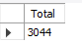
2.Top industry by funding
select IndustryVertical,sum(Amount) as TotalFunding
from finance_data
group by IndustryVertical order by TotalFunding desc limit 1
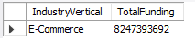

3.Top Location by funding
select Location,sum(amount) as Total from finance_data group by Location order by Total desc limit 1
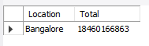
4.Top 10 Investors
select InvestorsName,sum(Amount) as TotalFunding
from finance_data
group by InvestorsName order by TotalFunding desc limit 10
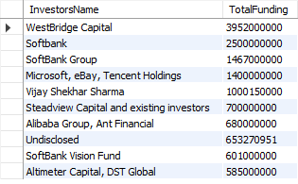

5.Top Investmenttype
select InvestmentType,count(*) as Total from finance_data group by InvestmentType order by Total desc limit 1
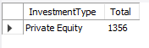

6.Top 5 Startups by funding
select startupName,sum(Amount) as TotalFunding
from finance_data
group by startupName order by TotalFunding desc limit 5
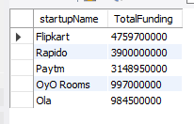

7.Which year has highest funding
select year(Date),sum(Amount) as TotalFunding
from finance_data
group by year(Date) order by TotalFunding desc limit 1
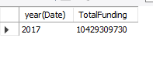
8.What are the top 10 largest individual funding deals?
select Date,startupname,IndustryVertical,Location,Amount from finance_data order by amount desc limit 10
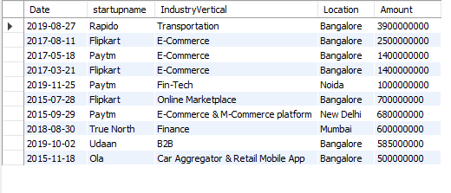

9. Which industries have the highest number of funded startups?
select IndustryVertical,count(*) as TotalStartups
from finance_data group by IndustryVertical order by TotalStartups desc limit 5;
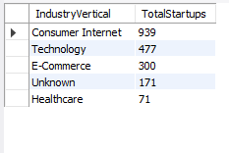
10.Which locations have the highest number of deals?
select Location,count(*) as Totaldeals from finance_data group by Location order by Totaldeals desc
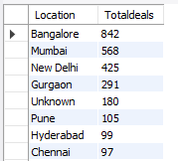

11.Which startup received the single largest deal?
select startupName,Amount from finance_data order by amount desc limit 1
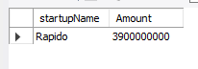

12.Which funding types have the highest total funding?
select Investmenttype,sum(Amount) as TotalFunding
from finance_data
group by Investmenttype order by TotalFunding desc limit 1
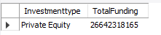

13. Which industries have the highest undisclosed funding percentage?
select IndustryVertical,count(*) as Total
from finance_data
where Isamountdisclosed=0
group by IndustryVertical order by Total desc
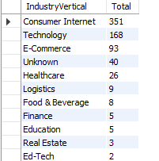

7. Power BI Dashboard Contents

KPIs
- Total Funding
- Total Deals
- Total Investors
- Average Deal Size
- Total Startups
8. Key Insights

Funding peaked in 2019
Indicates strongest investor confidence.

E-commerce & Technology received the highest funding
These sectors dominate innovation.

Bengaluru leads in number of deals
It is India’s largest startup hub.

Seed & Private Equity are most common investment types
Early-stage funding dominates the ecosystem.

Softbank & Tiger Global are top investors
They appear frequently in large deals.

Many deals are undisclosed
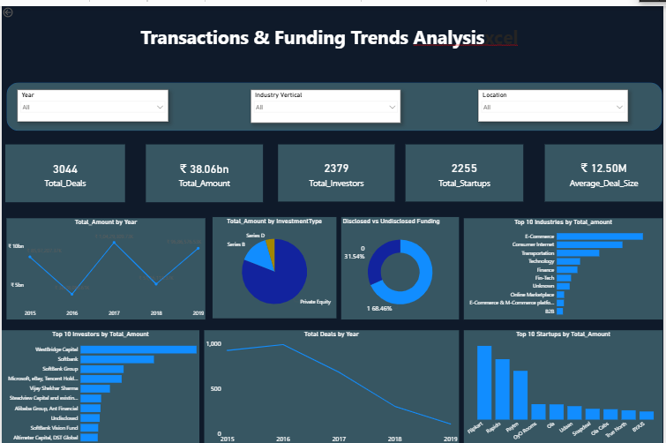

9. Conclusion
The Indian startup ecosystem grew rapidly between 2015-2019, with major funding concentrated in:
- E-commerce
- Technology
- FinTech
- Consumer Internet
Bengaluru emerged as the strongest startup hub, attracting maximum funding and investor activity.
The Power BI dashboard provides an interactive and visual understanding of:
- Funding trends
- Investor behavior
- Industry performance
- Startup growth
This project demonstrates strong skills in data cleaning (Python),
data analysis (MySQL), and
data visualization (Power BI).

